**Device Driver for Seven Segment Display**

**Summary**

This project involves interfacing seven segment display to raspberry pi 3 by controlling its GPIO pins. The GPIO pins are in turn controlled by accessing the hardware registers of BCM2387 SOC’s GPIO peripherals. The device memory is mapped to kernel’s virtual address space using ioremap function. A character driver is written in order to control the seven-segment display. The device driver obtains the user space request over copy_from_user() system call. Based on this user input, the GPIO pins are controlled and the corresponding input number is displayed on the seven-segment display. Apart from this a sysfs device object file is created in the sys/class directory. The user can also specify the input number using sysfs interface.

**Hardware Schematic**

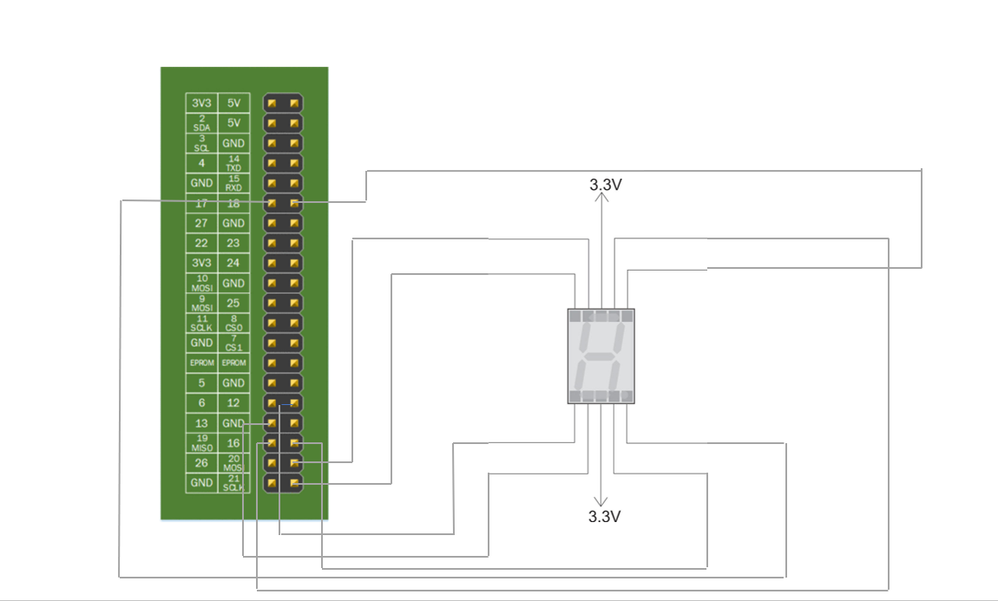

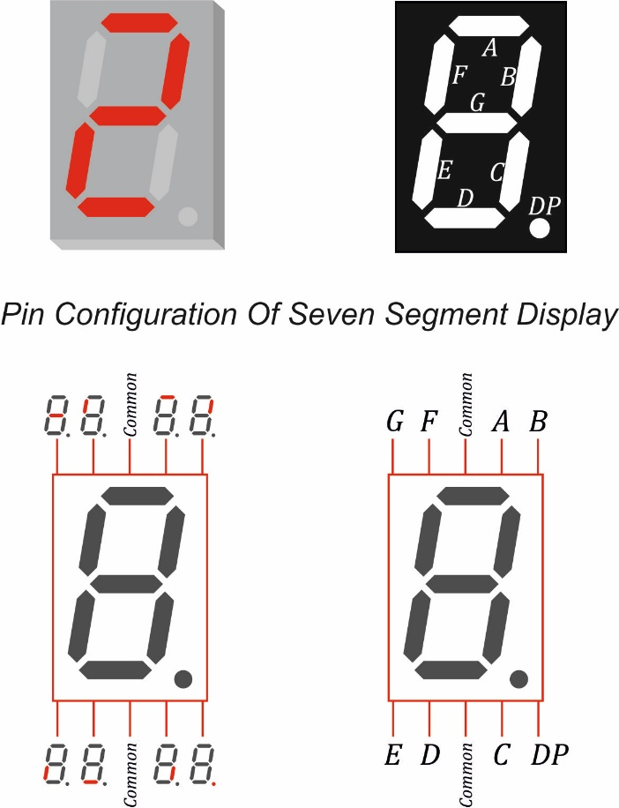 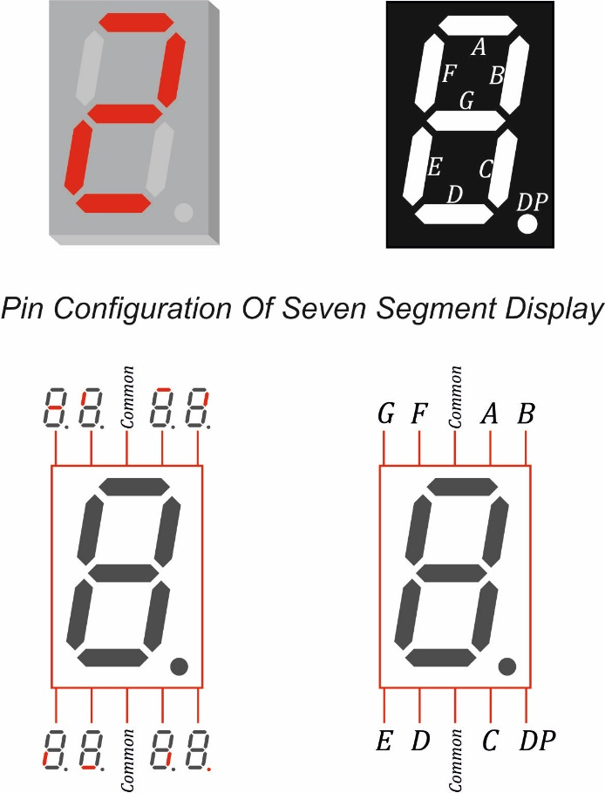 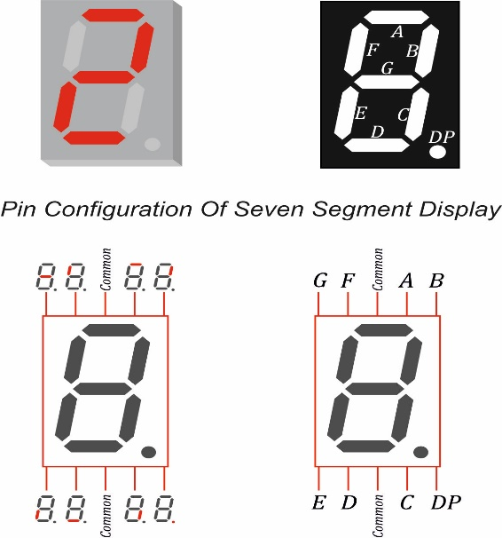

**Hardware Snapshot**

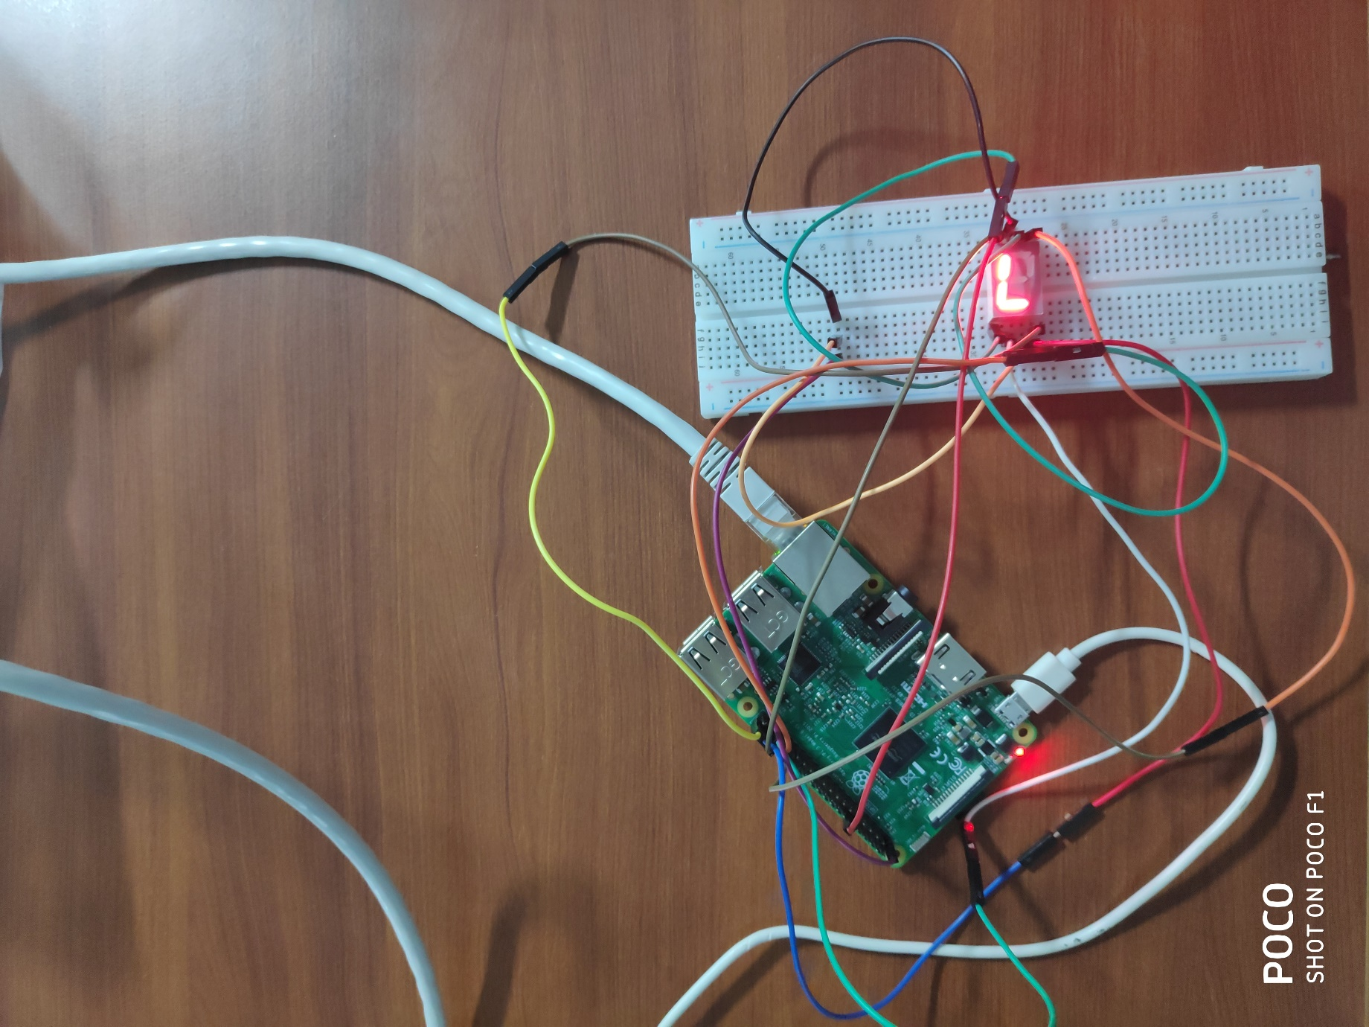

**Firmware Description**

Firmware is present in the folder Device Driver for Seven Segment Display/Firmware. Relevant file is GPIO_Register_Access. It gives a detail description about the functions used in raspberry pi 2 SOC- BCM 2385 to access its GPIO registers. The same functions can be used for raspberry pi 3 also.

**Driver Description**

Device driver is present in the folder Device Driver for Seven Segment Display /kernel_module. Relevant files are seven_segment.c , and Makefile. Device driver is a character driver. "make all” is used to build .o and .ko files. “sudo insmod filename.ko is used to insert the kernel module and “sudo rmmod filename” is used to remove the kernel module. “lsmod” gives the list of the kernel modules in the source tree.

**Build Process:**

* sudo rmmod seven_segment
* make clean
* make all
* sudo insmod seven_segment.ko
* lsmod

**User Application**

User program is present in the folder Device Driver for Seven Segment Display /user_application. Relevant files are user.c, and Makefile. "make all” is used to compile the user space application. “make permission” is to give permission to the user application to access the kernel module. “make run” is used to run the user program. The input number to be displayed is given. Another way to give user input is by going into “sys/class/Seven_segment_Display/7-segment-display” and then enter into the root by giving the command “sudo su”. The user input is given using the command “sudo echo ‘input_number’ > period”

**Build Process:**

* make all
* make permission
* make run

(or)

* cd sys/class/Seven_segment_Display/7-segment-display
* sudo su
* sudo echo ‘input_number’ > period

**Possible Errors**

The possible errors encountered while developing this project is present in the folder Device /Driver for Seven Segment Display . The relevant file is Possible_errors.

**References**

* <https://www.airspayce.com/mikem/bcm2835/>
* <https://elinux.org/RPi_BCM2835_GPIOs>

**Authors**

Swetha Bulusu & Malaika Afra Taj, ME Embedded Systems, BITS PILANI - KK Birla Goa Campus.

**License**

* This project is licensed under the GNU-GPL License.